1]

import React from 'react';

function App() {

return (

<div>

<h1>Welcome to My First React App!</h1>

<p>This is a simple React application.</p>

</div>

);

}

export default App;

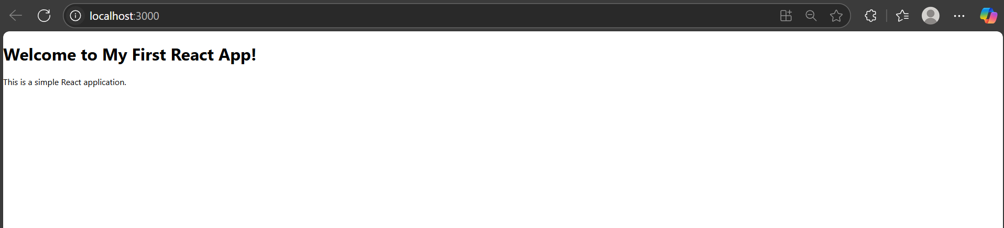

Home.js:

import React from 'react';

function Home() {

return (

<div>

<h2>Home Page</h2>

<p>Welcome to the Student Application</p>

</div>

);

}

export default Home;

About.js:

import React from 'react';

function About() {

return (

<div>

<h2>About Page</h2>

<p>This app provides information about students.</p>

</div>

);

}

export default About;

Contact.js:

import React from 'react';

function Contact() {

return (

<div>

<h2>Contact Page</h2>

<p>Contact us at: student@app.com</p>

</div>

);

}

export default Contact;

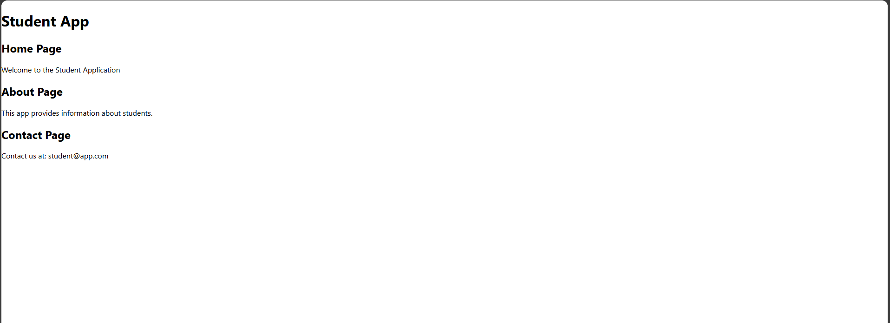

3]

CalculateScore.js:

import React from 'react';

import '../Stylesheets/mystyle.css';

function CalculateScore() {

const name = "Aditi";

const school = "Bright Future High School";

const totalMarks = 455;

const goalMarks = 500;

const average = (totalMarks / goalMarks) \* 100;

return (

<div className="score-card">

<h2>Student Score Calculator</h2>

<p><strong>Name:</strong> {name}</p>

<p><strong>School:</strong> {school}</p>

<p><strong>Total Marks:</strong> {totalMarks}</p>

<p><strong>Goal Marks:</strong> {goalMarks}</p>

<p><strong>Average Score:</strong> {average.toFixed(2)}%</p>

</div>

);

}

export default CalculateScore;

App.js:  
import React from 'react';

import './App.css';

import CalculateScore from './Components/CalculateScore';

function App() {

return (

<div className="App">

<CalculateScore />

</div>

);

}

export default App;

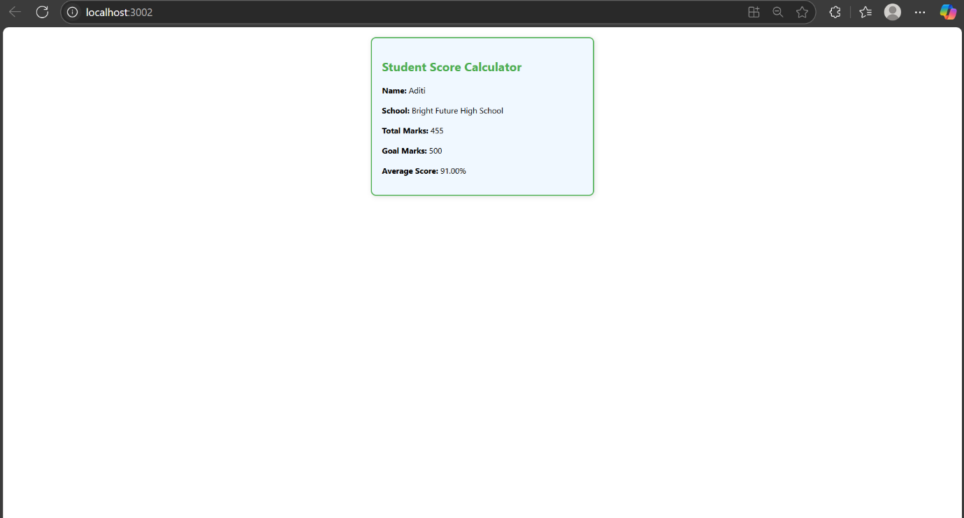

4]

Posts.js:

import React, { Component } from 'react';

import Post from './Post';

class Posts extends Component {

constructor(props) {

super(props);

this.state = {

posts: [],

error: null

};

}

loadPosts = () => {

fetch('https://jsonplaceholder.typicode.com/posts')

.then(response => response.json())

.then(data => {

const postList = data.map(post => new Post(post.id, post.title, post.body));

this.setState({ posts: postList });

})

.catch(error => {

this.setState({ error });

});

};

componentDidMount() {

this.loadPosts();

}

componentDidCatch(error, info) {

alert("An error occurred: " + error.toString());

}

render() {

const { posts } = this.state;

return (

<div>

<h2>Blog Posts</h2>

{posts.length > 0 ? (

posts.map(post => (

<div key={post.id} style={{ marginBottom: '20px' }}>

<h3>{post.title}</h3>

<p>{post.body}</p>

</div>

))

) : (

<p>Loading posts...</p>

)}

</div>

);

}

}

export default Posts;

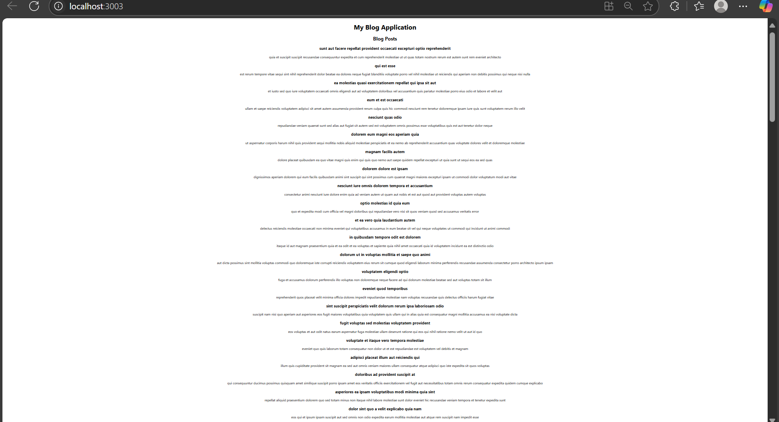

CohortDetails.module.css:

.box {

width: 300px;

display: inline-block;

margin: 10px;

padding: 10px 20px;

border: 1px solid black;

border-radius: 10px;

}

/\* Style for <dt> \*/

dt {

font-weight: 500;

}

CohortDetails.js

import React, { Component } from 'react';

import styles from './CohortDetails.module.css';

class CohortDetails extends Component {

constructor(props) {

super(props);

this.state = {

cohorts: [

{

id: 1,

name: 'React Fundamentals',

status: 'ongoing',

trainer: 'Jane Doe',

startDate: '2024-06-01',

endDate: '2024-08-15'

},

{

id: 2,

name: 'Java Spring Boot',

status: 'completed',

trainer: 'John Smith',

startDate: '2024-03-10',

endDate: '2024-05-25'

}

]

};

}

render() {

return (

<div>

<h2>My Academy Cohorts</h2>

{this.state.cohorts.map((cohort) => (

<div key={cohort.id} className={styles.box}>

<h3 style={{ color: cohort.status === 'ongoing' ? 'green' : 'blue' }}>

{cohort.name}

</h3>

<dl>

<dt>Status:</dt>

<dd>{cohort.status}</dd>

<dt>Trainer:</dt>

<dd>{cohort.trainer}</dd>

<dt>Start Date:</dt>

<dd>{cohort.startDate}</dd>

<dt>End Date:</dt>

<dd>{cohort.endDate}</dd>

</dl>

</div>

))}

</div>

);

}

}

export default CohortDetails;

